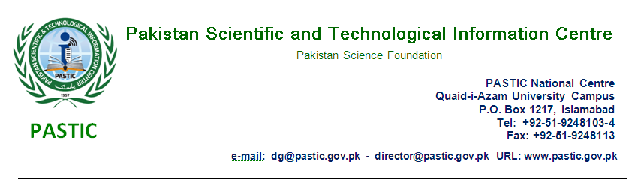

INVITATION TO BID

Pakistan Scientific and Technological Information Centre (PASTIC) intends to invite sealed bids from well-reputed Firms/General Order Suppliers deals in Printing Material, Paper Products, Printing Chemicals and making of Printing Plates. Only those (non-black listed) firms are eligible to participate in tender process which are Registered with Tax Department & having valid NTN & GST numbers and are on Active Tax Payer List (ATL).

A complete set of Tender document and detail specification of the items along with terms & condition for the procurement can be purchased on cash payment of Rs.1000/-(non-refundable) for each set during (Monday to Friday) from (10:00am to 4:00pm.) from the undersigned. It is further advised that receipt for Rs.1000/- may also be attached on top of the tender set, without receipt tender will not be accepted.

All participants are requested to attached earnest money of Rs. 50,000/- in shape of Bank draft/ Pay order in favor of Pakistan Scientific and Technological Information Centre, Islamabad, which will be retained till the expiry of quotation validity period and to submit (item wise) quotations latest by 27.11.2018 till 11:00 am which will be opened on the same day at 11:30 am at PASTIC Committee Room, Islamabad in the presence of the bidders or their representatives, who wish to attend.

(Muhammad Ghazi)
Additional Director (Admin)
PASTIC National Centre Islamabad
Ph. 051-9248105

